PUYA Arm M0+ Projects

System Notes:

The system has 4 variations. The host to co-processor communication is either via SPI or UART, and the co-processor to sensor communication is either SPI or I2C. The difference between the host communication modes does not affect program flow.

Common Notes:
The system can be in either COMMAND mode, or AUTO mode. Commands are only valid in one mode or the other. COMMAND mode commands are 32bit and include both an address and parameter length. AUTO mode commands are 16 bit and include only an address. AUTO mode commands do not have parameters. The “StartAuto” command is used to enter AUTO mode from COMMAND mode. There are two ways to go back to COMMAND mode. 1) The “EndAuto” command is sent. 2) Missing x number of synch pulses.

SPI Sensor System Notes:
The SPI system is much more flexible than the I2C system. The SPI system is not designed for a particular magnetometer, imu, etc. First, sensor configuration is completed through a series of “SingleTXRX” commands. Then the master sends a list of commands that the co-processor will execute in AUTO mode using the command “SetAutoSequence”. Look below to see the 3 different AUTO commands, or parameters to the “SetAutoSequence” command. The master can configure up to 4 different automatic command sequences (0x00, 0x01, 0x02, 0x03). After that, “StartAuto” is used to start the state machine and start sampling sensors. The 1khz synchronization command indicates which automatic sequence should be executed in a particular 1ms period. (0x00, 0x01, 0x02, 0x03). All RX’s in the auto sequence are concatenated into the data packet that will be sent in the next 1ms period.

I2C Sensor System Notes:
The system only supports a SINGLE I2C MMC5603 device per co-processor. Sensor configuration is completed through a series of “SingleTXRX” commands. After that, “StartAuto” is used to start the state machine and synchronize sampling with the sensor timing. The 1khz synchronization command is always 0x00, and the data packet is 25 bytes. This allows for 0, 1, or 2 sensor samples to be sent in each transaction. This is necessary because of 1khz timing aliasing between the host and MMC5603 device.

Other:
PUYA devices do not do hot-plug scanning on their own
The master scan’s it’s ports and recognizes PUYA devices via the WhoAmI register
PY32F030F1xU has 18 GPIO’s, but 3 should be reserved for easy programming, so 15 free.

COMMAND mode command structure:

Commands are 32 bits. Commands are followed by a pause, and then the parameters are sent. The length in bytes of the parameters is specified as part of the command.
31-24 | 23-16 | 15-0
Command Code | Address | Parameter Length

AUTO mode command structure:

Commands are 16 bits. AUTO commands do not support parameters.
31-24 | 23-16
Command Code | Address

Valid Addresses:
All commands contain an address. Currently, the only valid addresses are listed below. (This is primarily used to allow both a SPI co-processor and an I2C co-processor to communicate on the same ommo-comm UART)

b’0000 0000 | Broadcast, received by all co-processors
b’0000 0001 | Received only by SPI output co-processors
b’0000 0010 | Received only by I2C output co-processors

Valid Commands in COMMAND mode:

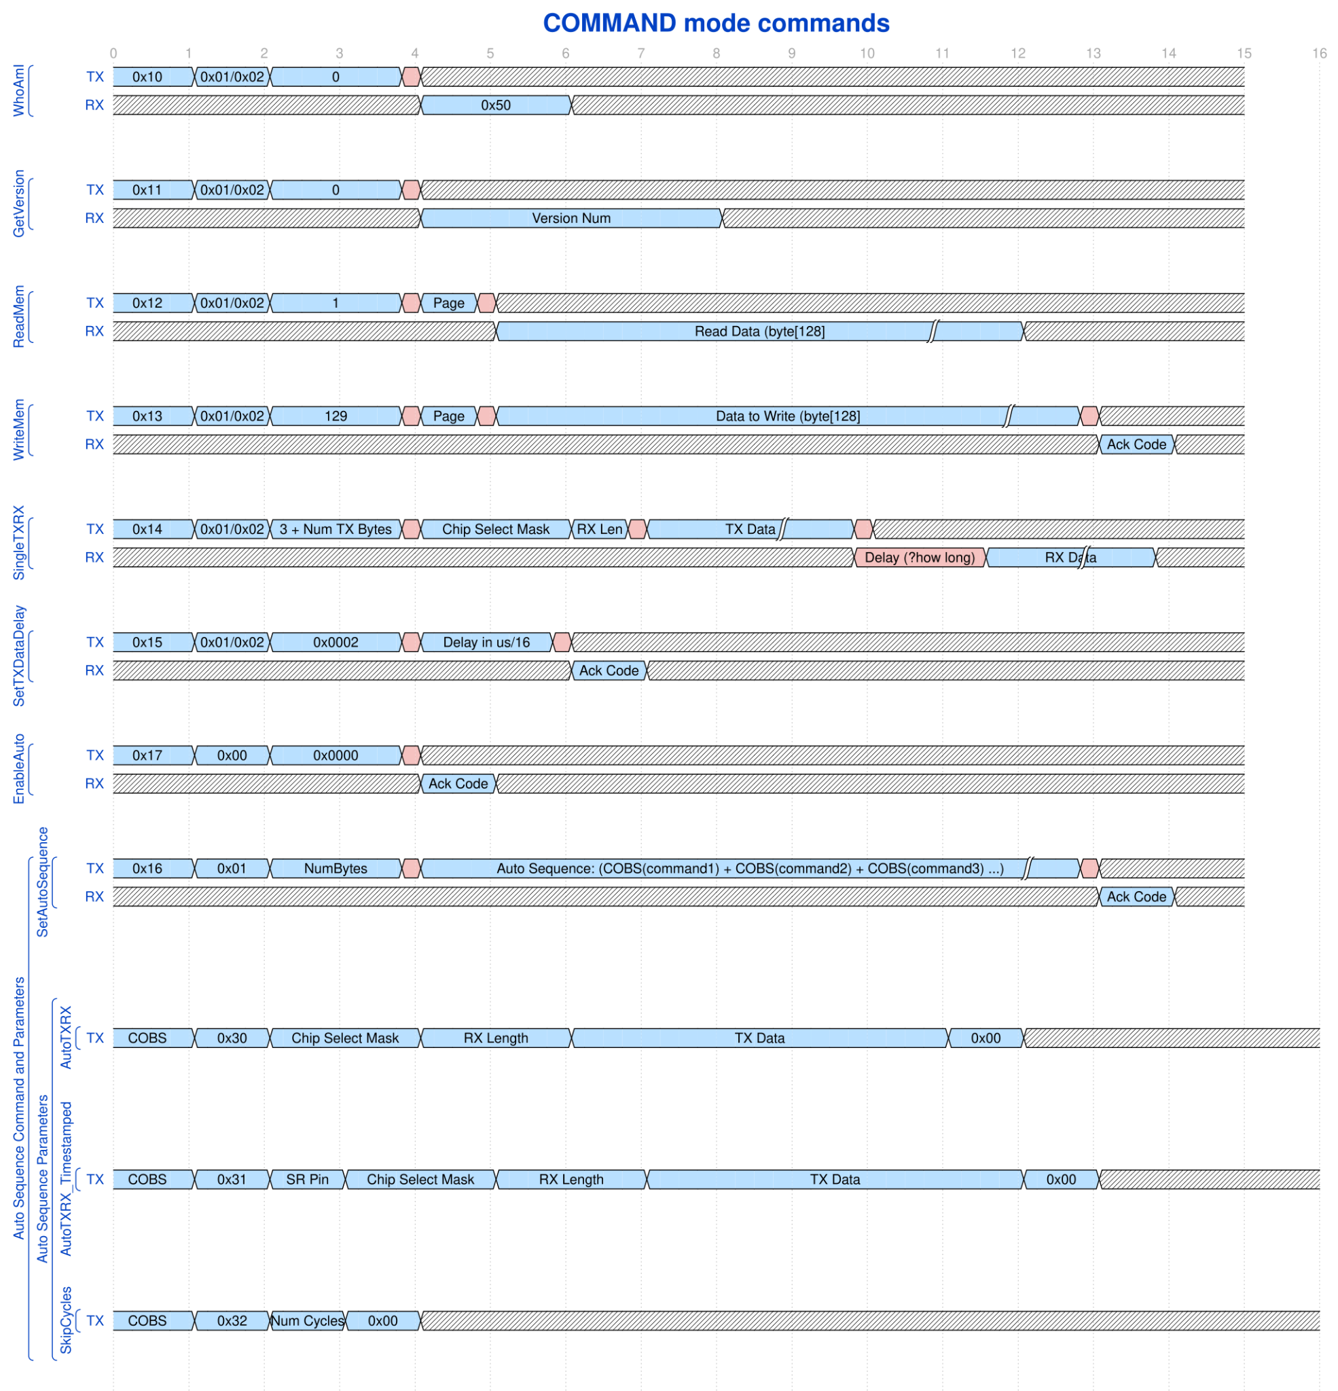
WhoAmI:
- Parameters:
  - None
- Return:
  - Fixed Manufacturer’s Product Code: 0x50

GetVersion:
- Parameters:
  - None
- Return:
  - (uint32) Current software version

ReadMem:
- Description:
  - The co-processor supports reading and writing a memory area of 2048 bytes. The memory area is divided into 16 x 128 byte pages. The ReadMem command reads a single page from this memory block.
- Parameters:
  - (byte) Page
    - This is the page address to read and return. Valid values are 0x00-0x0F.
- Return:
  - (byte[128]) Data
    - This is the data from the selected page.

WriteMem:
- Description:
  - The co-processor supports reading and writing a memory area of 2048 bytes. The memory area is divided into 16 x 128 byte pages. The WriteMem command writes a single page into this memory block.
- Parameters:
  - (byte) Page
    - This is the page address to write. Valid values are 0x00-0x0F.
  - (byte[128]) Data
    - This is the 128 byte data chunk to write into the selected page.
- Return:
  - (byte) Ack
    - TBD: Will indicate success or and error code

SingleTXRX:
- Description:
  - This command will immediately send a TX command to a SPI sensor on a specific chip select line (multiple chip select lines can be specified. This would only be valid for a broadcast command with no RX data). After the transmission it will do a SPI sensor read for the desired number of bytes (if rx_len > 0).
- Parameters:
  - (uint32) chip_select_mask
    - A bitmask that indicates which CS lines should be activated. Bit 0 = CS0.
  - (byte) rx_len
    - Indicates how much data should be read back from the sensor after the transmit. If this is 0, then no data is read back from the sensor and no data is returned.
- Return:
  - (byte[rx_len]) The data read back from the sensor

SetTXDataDelay:
- Description:
  - This command instructs the co-processor to place a delay after the synch byte and before starting the transmission of the last data packet. The purpose of this is to allow more than one co-processor to send data packets back to the master over the UART bus without their data colliding.
- Params:
  - (uint16) delay
    - This is the amount of time to delay. The units are in 1/16us ticks. Eg. Value 16 would equal 16 * 1/16 = 1us.
- Return:
  - (byte) Ack
    - TBD: Will indicate success or and error code

SetAutoSequence:
- Description:
  - This command takes a list of operations that will be executed following the SYNCH rx. Each commands is run through the COBs algorithm to remove 0x00 values and then terminated with a 0x00. Then all of the commands are concatenated. The concatenated byte[] is the parameter to this command.
- Actual Params:
  - (byte[]) Auto Sequence
    - The concatenated list of COBs’d commands.
- Encoded Commands:
  - AutoTXRX:
    - Description:
    - Params:
    - Return:
  - AutoTXRX_Timestamped:
    - Description:
    - Params:
    - Return:
  - SkipCycles:
    - Description:
    - Params:
    - Return:
- Return:
  - (byte) Ack
    - TBD: Will indicate success or and error code

Valid Commands in AUTO mode:
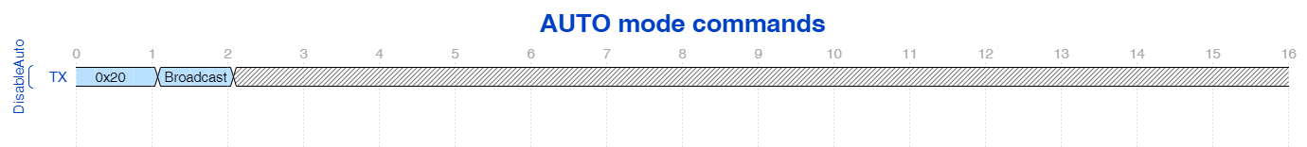
There is only one AUTO mode command. DisableAuto which exits AUTO mode and returns the processor to COMMAND mode.

Master UART Sensor SPI

Nordic ←UART→ PUYA ←SPI→ SENSOR

Purpose: Samples MMC5983 and ICM42605 sensors and reports data over a single wire UART interface.

IO’s:
- Power
- Gnd
- Oscillator out
- UART tx/rx
- Sample Complete Signal 0-n (Typically only 1 used for the IMU)
- Sensor MISO
- Sensor MOSI
- Sensor CLK
- Sensor CS0-CS? (Maximum 10 without IMU, 13 without debugging and IMU)

Auto Mode:
- Co-processor waits for a falling edge on the UART line
  - The time of this edge is captured. And the system clock is adjusted to make the time between these edges to be 15984/16000 ms.
- Co-processor IMMEDIATELY with known timing sends the first command in the auto command list. “T1” in the timing diagram below.
- Simultaneously the Co-processor
  - Executes each remaining command in the command list in order.
  - Transmits the previous sampler period’s resulting RX data over the UART line.
- Co-processor listens for UART commands until 100us before the expected timing synch signal.
  - The only supported command at this time is DISABLE_AUTO

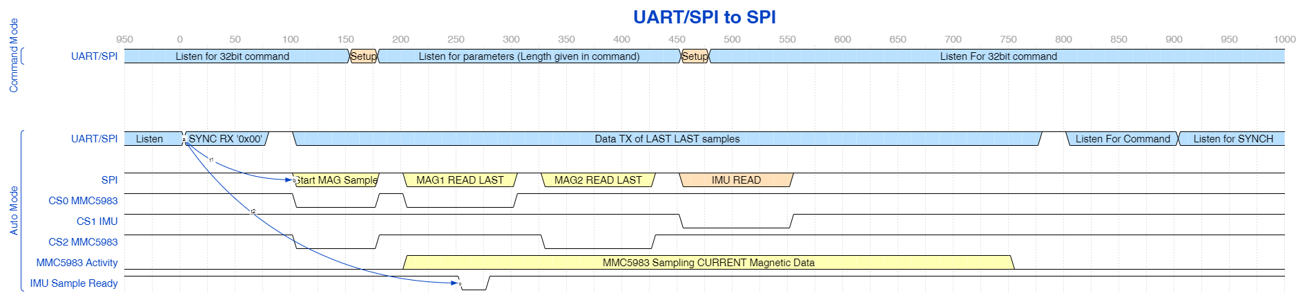

UART in I2C out
Nordic <-> UART/SPI <-> PUYA <-> I2C <-> Sensor

Purpose: Samples a SINGLE MMC5603 sensor and reports the data over a single wire UART interface.

IO’s:
- Power
- Gnd
- Oscillator out
- UART tx/rx
- Sensor SCK
- Sensor SDA

Auto Mode:

The MMC5603 samples at its own rate. This software will use a PID to determine when the sample is finished. It does this by reading the sample finished bit right before reading the data. Then balancing its read timing back and forth slightly so that it reads “sample finished” half of the time and “sample not finished” the other half.

This means that the CPU may be executing code during the timing signal, as well as during the read sensor data request. I think this will be manageable.

Secondly, we do not precisely know the sample rate of the MMC5603, but it is around our sample rate. This means, depending on sample time aliasing, the data packet could contain 0-2 real packets. As a result we will always send enough data to hold 2 packets with a bit mask that indicates which of the data samples are valid. This format is as follows:

<SAMPLE DATA (9 bytes)><TEMP (1 byte)><TIMESTAMP (2 bytes)> …
<SAMPLE DATA (9 bytes)><TEMP (1 byte)><TIMESTAMP (2 bytes)><SAMPLE_VALID_MASK>

Timing Diagram:

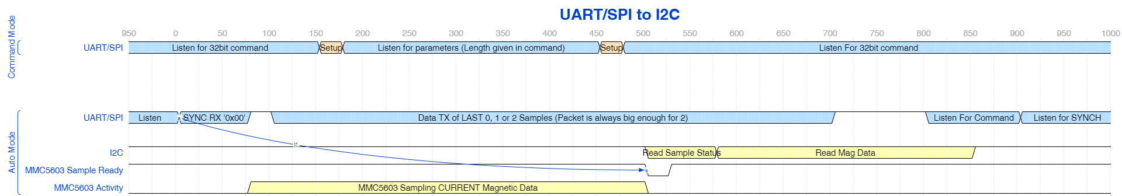

SPI in SPI out

IO’s:
- Power
- Gnd
- Master MISO
- Master MOSI
- Master CLK
- Master CS
- Sample Complete Signal 0-n (Typically only 1 used for the IMU)
- Sensor MISO
- Sensor MOSI
- Sensor CLK
- Sensor CS0-CS? (Maximum 8 without IMU, 11 without debugging and IMU)

SPI in I2C out

IO’s:
- Power
- Gnd
- Master MISO
- Master MOSI
- Master CLK
- Master CS
- Sensor SCK
- Sensor SDA

Notes:
10/5/2023

SPI in I2C out
- Junyu is working on this currently. All hardware pieces are working.
- Could be done soon with sensor sampling - PUYA -> I2C
- Not sure if Nordic <-> PUYA has been tested. No protocol is implemented

Master UART Sensor SPI
Nordic ←UART→ PUYA ←SPI→ SENSOR

SPI in SPI out
- Tested PUYA -> SPI Device (MMC5983)

UART in I2C out
Nordic <-> UART/SPI <-> PUYA <-> I2C <-> Sensor

—-

DMA Low Level Driver
- SPI half duplex DMA low level driver,
  - TBD
- I2C DMA low level driver,
  - Junyu
- UART Half duplex DMA low level driver
  - Global Silicon
- Chip has 3 DMA channels, each protocol will use single DMA channel. reconfigure driver for transmit and receive, including DMA and pin assignments

Clock synchronization implementation using the clock adjust registers. Will verify clock synchronization accuracy post implementation
- Global Silicon responsibility

I2C MMC5603 Handler
- Actual sampling state machine implementation
  - Ommo Implementation

SPI auto sequence state machine & data structure
- Actual sampling state machine implementation
  - Global silicon implementation

master/ co-processor protocol decoding (co-processor command interface)
- The command set is largely done, may have some tweaks pre-implementation
  - Richard defines
- During implementation there will be iterations
  - Global silicon implementation
  - Richard in feedback loop

Error Detection
- Global Silicon
- Need this first with a retry mechanism. May not be able to correct

CRC/ Redundancy Investigation & implementation - (Error correction)
- Global Silicon
- Unclear whether this will be possible. May not be required with fully determinate detection

Bootloader investigation and implementation
- Unknown scope. There is a PUYA bootloader but documentation is scarce
- Work this development in with hardware schedule

Read & Write - Flash memory (EEPROM replacement)
- Responsible Party - TBD

Auto TxRx - Implement Timestamped Reads (IMU support)
- This can be completed after everything else
- Responsible party is TBD

Timing
- BL Requirements by end of oct
- Schematic capture start end of oct/early nov for sensor hardware & master SIU
  - Mechanical contact review & interfaces in October
- Layout complete by 2nd week nov for first proto -
  - Hand asm for sensor proto with dev kit master for testing - 2-3 weak L/T
  - Assembled master SIU overseas - 6 week lead time
- Early december - 1st proto sensor test

